St Andrew's Church

Orford with Longford

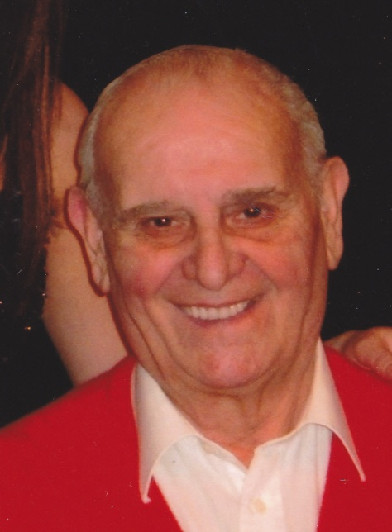

**Ron Hollingsworth**

**24th June 1929 - 4th January 2013**

*Jesus said, “I am the resurrection and I am the life; those who believe in me, though they die, yet shall they live, and whoever lives and believes in me shall never die.”*

**Reception into Church**

**Sunday 13th January 2013**

*The priest leads the procession into church, reading the sentences from scripture.*

Please stand until Ron’s family have taken their place, then sit or kneel for the service.

#### Introduction and opening words

Priest: In the name of the Father, and of the Son, and of the Holy Spirit. **Amen**

We receive the body of our brother Ron with confidence in God, the giver of life, who raised our Lord Jesus from the dead.

#### Sprinkling the coffin with water

The coffin is sprinkled with holy water taken from the font. It is a reminder of baptism and the promise of eternal life that flows from it.

Priest: With this water we call to mind Ron’s baptism. As Christ went through the deep waters of death for us, so may he bring us to the fullness of resurrection life with Ron and all the redeemed.

The Paschal Candle is lit to remind us of our Lord’s victory over the power of death.

Priest: Jesus Christ is the light of the world

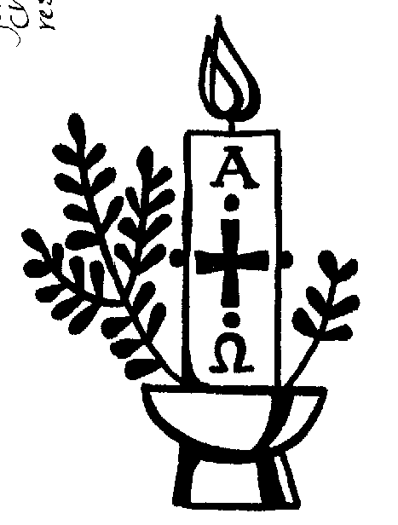All: a light no darkness can quench

Priest: Stay with us, Lord, for it is evening:

All: and the day is almost over

Priest: Even the darkness is not dark for you:

All: and the night shines like day

Priest: Let your light scatter the darkness:

All: and fill your church with your glory

**A reading from the letter to the Romans** *(verses from chapter 8)*

I consider that our present sufferings are not worth comparing with the glory that will be revealed in us. If God is for us, who can be against us? He who did not spare his own Son, but gave him up for us all – how will he not also, along with him, graciously give us all things? Who will bring any charge against those whom God has chosen? It is God who justifies. Who is he that condemns? Christ Jesus, who died-more than that, who was raised to life – is at the right hand of God and is also interceding for us. Who shall separate us from the love of Christ? Shall trouble or hardship or persecution or famine or nakedness or danger or sword? No, in all these things we are more than conquerors through him who loved us. For I am convinced that neither death nor life, neither angels nor principalities nor powers, neither the present nor the future, neither height nor depth, nor anything else in all creation, will be able to separate us from the love of God that is in Christ Jesus our Lord.

This is the word of the Lord

All: Thanks be to God

#### Verses from Psalm 27

All say together:

1. The Lord is my light and my salvation

whom then shall I fear?

the Lord is the stronghold of my life

of whom shall I be afraid?

4. One thing I have asked from the Lord which I will require

that I may dwell in the house of the Lord

all the days of my life

5. to see the fair beauty of the Lord:

and to seek his will in the temple.

6. For he will hide me under his shelter in the day of trouble

and conceal me in the shadow of his tent

and set me high upon a rock.

8. And I will offer sacrifices in his sanctuary with exultation:

I will sing, I will sing praises to the Lord.

Glory to the Father and to the Son:

and to the Holy Spirit:

As it was in the beginning is now:

and shall be for ever. Amen

#### The Prayers

Priest: Let us pray:

Prayers for Ron, his family and friends follow.

**The Lord’s Prayer:**

Priest: Let us pray for the coming of the Kingdom in the words our Saviour gave us:

All: Our Father, who art in heaven,

hallowed be thy name,

Thy kingdom come, thy will be done,

on earth, as it is in heaven.

Give us this day our daily bread,

and forgive us our trespasses,

as we forgive those who trespass against us.

And lead us not into temptation,

but deliver us from evil.

For thine is the kingdom,

the power and the glory,

for ever and ever. Amen.

**A pall is spread over the coffin** *during which part of ‘In Paradisium’ from Faure’s Requiem is played*

Priest: We are already God's children,  
but what we shall be has not yet been revealed.  
Yet we know that when Christ appears we shall be like him,  
for we shall see him as he is.

**Symbols of Ron’s faith and life** are then placed on the coffin*:*

***A Bible*** Lord Jesus Christ,  
your living and imperishable word brings us to new birth.  
Your eternal promises to us and to Ron are proclaimed in your Holy Word.

***A Crucifix*** Lord Jesus Christ,  
for love of Ron and each one of us  
you bore our sins on the cross.

***A Beret*** Lord Jesus Christ,

your kingdom is one of justice and peace.

Welcome Ron and all the faithful

into your eternal kingdom.

***A Photograph*** Merciful Father and Lord of all life, we praise you that you have made us in your image to reflect your truth and light. We thank you for the life of your son Ron, for the love and mercy he received from you and showed among us, for all that was good in his life, and especially for the memories we treasure today.

Priest: Let us pray:

Keep watch, dear Lord, with those who work, or watch, or weep this night, and give your angels charge over those who sleep. Enfold in your loving arms our brother Ron who now rests in your eternal peace, and give him rest, this night and always. **Amen**

Rest eternal grant unto him O Lord

**All: And let light perpetual shine upon him. Amen**

Priest: May Christ, who out of defeat

brings new hope and a new future,

fill you with his light, his love and his new life;

and the blessing of God almighty

the Father, the Son and the Holy Spirit,

be with you tonight and always. **Amen**

## **The Requiem**



#### Monday 14th January 2013

*Before the service begins,* Highland Cathedral *and* God bless the Prince of Wales *will be played*.

#### THE GATHERING

**Introit Hymn:** ‘Christ is our corner-stone’

Christ is our corner-stone,

on him alone we build;

with his true saints alone

the courts of heaven are filled:

on his great love

our hopes we place

of present grace

and joys above.

O then with hymns of praise

these hallowed courts shall ring;

our voices we will raise

the Three in One to sing;

and thus proclaim

in joyful song,

both loud and long,

that glorious name.

Here may we gain from heaven

the grace which we implore;

and may that grace, once given,

be with us evermore,

until that day

when all the blest

to endless rest

are called away.

Priest: We meet in the name of Jesus Christ, who died and was raised to the glory of God the Father. Grace and mercy be with you

All: and also with you.

We have come here today to remember before God our brother Ron; to give thanks for his life; to commend him to God our merciful redeemer and judge; to commit his body to be buried, and to comfort one another in our grief.

Priest: Let us pray:

Almighty God, you judge us with infinite mercy and justice and love everything you have made. In your mercy turn the darkness of death into the dawn of new life, and the sorrow of parting into the joy of heaven; through our Saviour, Jesus Christ. **Amen**

#### Prayers of Penitence

Priest: As children of a loving heavenly Father, let us ask his forgiveness, for he is gentle and full of compassion.

(After a period of silent reflection)

All: Most merciful God, Father of our Lord Jesus Christ, we confess that we have sinned in thought, word and deed. We have not loved you with our whole heart. We have not loved our neighbours as ourselves. In your mercy forgive what we have been, help us to amend what we are, and direct what we shall be; that we may do justly, love mercy, and walk humbly with you, our God. Amen

Priest: Almighty God, who forgives all who truly repent, have mercy upon you, pardon and deliver you from all your sins, confirm and strengthen you in all goodness, and keep you in life eternal; through Jesus Christ our Lord. **Amen.**

All GLORY to God in the highest, and peace to his people on earth. Lord

***(sing)* God, heavenly King, almighty God and Father, we worship you, we give you thanks, we praise you for your glory. Lord Jesus Christ, only Son of the Father, Lord God, Lamb of God, you take away the sin of the world: have mercy on us; you are seated at the right hand of the Father: receive our prayer. For you alone are the Holy One, you alone are the Lord, you alone are the Most High, Jesus Christ, with the Holy Spirit, in the glory of God the Father. Amen.**

**Collect:**

Merciful Father, hear our prayers and comfort us; renew our trust in your Son, whom you raised from the dead; strengthen our faith that Ron and all who have died in the love of Christ will share in his resurrection; who lives and reigns with you, in the unity of the Holy Spirit, one God, now and for ever. **Amen**

## **THE LITURGY OF THE WORD**

Please sit for

**A reading from the first letter of Peter** *(1 Peter 1. 3-9)*

read by Albert Yeamans.

At the end of the reading

Reader: This is the word of the Lord

All: Thanks be to God

**Gradual hymn:** *(please stand)* ‘Dear Lord and Father of mankind’

Dear Lord and Father of mankind,

forgive our foolish ways;

re-clothe us in our rightful mind,

in purer lives thy service find,

in deeper reverence praise,

in deeper reverence praise.

In simple trust like theirs who heard,

beside the Syrian sea;

the gracious calling of the Lord,

let us, like them, without a word

rise up and follow thee,

rise up and follow thee.

O Sabbath rest by Galilee!

O calm of hills above,

where Jesus knelt to share with thee

the silence of the eternity,

interpreted by love,

interpreted by love!

Drop thy still dews of quietness,

till all our strivings cease;

take from our souls the strain and stress,

and let our ordered lives confess

the beauty of thy peace,

the beauty of thy peace.

Breathe through the heats of our desire

thy coolness and thy balm;

let sense be dumb, let flesh retire;

speak through the earthquake, wind and fire,

O still small voice of calm,

O still small voice of calm.

#### THE GOSPEL

Priest: Alleluia, alleluia. God so loved the world that he gave his only Son.

All: Alleluia.

Hear the Gospel of our Lord Jesus Christ according to John *(Jn 14. 1-6)*

All: Glory to you, O Lord

*At the end*

Priest: This is the Gospel of the Lord

All: Praise to you, O Christ

#### The Address including family tributes

#### The Prayers

Priest: Let us pray

Leader: God of mercy, Lord of life, you have made us in your image to reflect your truth and light: we give you thanks for Ron, for the grace and mercy he received from you, for all that was good in his life, and for the memories we treasure today. Especially we thank you for Ron’s example of faith, love and friendship; for all that he has done to build up the life of the church, and for his dedication to, and love for, family life. We thank you for the way in which he has enriched our lives.

Leader: Lord in your mercy

All: hear our prayer.

Leader: Heavenly Father, you promised eternal life to those who believe. Remember for good your son Ronas we also remember him. Bring all who rest in Christ into the fullness of your kingdom where sins have been forgiven and death is no more.

Leader: Lord in your mercy

All: hear our prayer.

Leader: Loving Father, your mighty power brings joy out of grief and life out of death. Look in mercy on Renee, Janice and Carol, their families and all who mourn. Give them patient faith in times of darkness. Strengthen them with the knowledge of your love.

Leader: Lord in your mercy,

All: hear our prayer.

Leader: Compassionate Father, you are tender towards your children and your mercy is over all your works. Heal the memories of hurt and failure. Give us the wisdom and grace to use aright the time that is left to us here on earth, to turn to Christ and follow in his steps in the way that leads to everlasting life.

Leader: Lord in your mercy,

All: hear our prayer.

All: God of mercy, entrusting into your hands all that you have made

and rejoicing in our communion with all your faithful people,

we make our prayers through Jesus Christ our Saviour. Amen.

## **THE LITURGY OF THE SACRAMENT**

#### The Peace *(please stand)*

Priest: Jesus says: Peace I leave with you; my peace I give to you. Not as the world gives do I give you. Do not let your hearts be troubled, neither let them be afraid. Alleluia. The peace of the risen Lord be always with you

All: and also with you.

Priest: Let us offer one another a sign of peace.

[Everyone is invited to share the peace with one another].

**Offertory Hymn:** ‘Abide with me’

Abide with me; fast falls the eventide:

the darkness deepens; Lord, with me abide:

when other helpers fail, and comforts flee,

help of the helpless, O abide with me.

Swift to its close ebbs out life's little day;

earth's joys grow dim, its glories pass away;

change and decay in all around I see:

O thou who changest not, abide with me.

I need thy presence every passing hour;

what but thy grace can foil the tempter's power?

Who like thyself my guide and stay can be?

Through cloud and sunshine, Lord, abide with me.

I fear no foe with thee at hand to bless;

ills have no weight, and tears no bitterness,

Where is death's sting? Where, grave, thy victory?

I triumph still, if thou abide with me.

Hold thou thy cross before my closing eyes;

shine through the gloom, and point me to the skies:

heaven's morning breaks, and earth's vain shadows flee;

in life, in death, O Lord, abide with me.

#### EUCHARISTIC PRAYER E *(please kneel)*

Priest: The Lord is here.

All: His Spirit is with us.

Priest: Lift up your hearts.

All: We lift them to the Lord.

Priest: Let us give thanks to the Lord our God.

All: It is right to give thanks and praise.

Priest: Blessed are you, gracious God, creator of heaven and earth, giver of life, and conqueror of death. By his death on the cross, your Son Jesus Christ offered the one true sacrifice for sin, breaking the power of evil and putting death to flight. With all your saints

All: we give you thanks and praise.

Priest: Through his resurrection from the dead you have given us new birth into a living hope, into an inheritance which is imperishable, undefiled, and unfading. With all your saints

All: we give you thanks and praise.

Priest: The joy of resurrection fills the universe, and so we join with angels and archangels, with Ron and all your faithful people, evermore praising you and saying:

All: Holy, holy, holy Lord, God of power and might, heaven and earth are full of your glory. Hosanna in the highest. Blessed is he who comes in the name of the Lord. Hosanna in the highest.

Priest: We praise and bless you, loving Father, through Jesus Christ, our Lord; and as we obey his command, send your Holy Spirit, that broken bread and wine outpoured may be for us the body and blood of your dear Son.

On the night before he died he had supper with his friends and, taking bread, he praised you. He broke the bread, gave it to them and said: Take, eat; this is my body which is given for you; do this in remembrance of me.

When supper was ended he took the cup of wine. Again he praised you, gave it to them and said: Drink this, all of you; this is my blood of the new covenant, which is shed for you and for many for the forgiveness of sins. Do this, as often as you drink it, in remembrance of me.

So, Father, we remember all that Jesus did, in him we plead with confidence his sacrifice made once for all upon the cross. Bringing before you the bread of life and cup of salvation, we proclaim his death and resurrection until he comes in glory.

Priest: Praise to you, Lord Jesus:

All: Dying you destroyed our death, rising you restored our life:

Lord Jesus, come in glory.

Priest: Lord of all life, help us to work together for that day when your kingdom comes and justice and mercy will be seen in all the earth. Look with favour on your people, gather us in your loving arms and bring us with St Andrew and all the saintsto feast at your table in heaven. Through Christ, and with Christ, and in Christ, in the unity of the Holy Spirit, all honour and glory are yours, O loving Father, for ever and ever.

All: Amen.

Priest: Let us pray with confidence as our Saviour taught us

All: Our Father, who art in heaven, hallowed be thy name; thy kingdom come; thy will be done; on earth as it is in heaven. Give us this day our daily bread. And forgive us our trespasses, as we forgive those who trespass against us. And lead us not into temptation; but deliver us from evil. For thine is the kingdom, the power and the glory, for ever and ever. Amen.

Priest: Every time we eat this bread and drink this cup,

All: we proclaim the Lord’s death until he comes.

All: Lamb of God, you take away the sin of the world, have mercy on us.

Lamb of God, you take away the sin of the world, have mercy on us.

Lamb of God, you take away the sin of the world, grant us peace.

Priest: Jesus is the Lamb of God who takes away the sin of the world.

Happy are those who are called to his supper.

All: Lord, I am not worthy to receive you, but only say the word and I shall be healed.

Holy Communion is administered at the front of Church. Everyone is warmly invited to receive Holy Communion at this Eucharist. Those who prefer to receive a blessing are also invited to come forward at the same time.

**During Communion:**

*A recording of* Lead kindly light with Last Post *will be played, followed by:*

Be still, for the presence of the Lord, the Holy One is here;

Come bow before him now with reverence and fear.

In Him no sin is found, we stand on holy ground;

Be still, for the presence of the Lord, the Holy One is here.

Be still, for the glory of the Lord, is shining all around;

He burns with holy fire, with splendour He is crowned.

How awesome is the sight, our radiant King of light;

Be still, for the glory of the Lord, is shining all around.

Be still, for the power of the Lord is moving in this place;

He comes to cleanse and heal, to minister His grace.

No work too hard for Him, in faith receive from Him;

Be still, for the power of the Lord is moving in this place.

#### Prayer After Communion:

Priest: Gracious God, we thank you that in your great love you have fed us with the spiritual food and drink of the body and blood of your Son Jesus Christ and have given us a foretaste of your heavenly banquet: grant that this sacrament may be to us a comfort in affliction and a pledge of our inheritance in that kingdom where there is no death, neither sorrow nor crying, but fullness of joy with all your saints; through Jesus Christ our Saviour. **Amen**

All: Heavenly Father, in your Son Jesus Christ you have given us a true faith and a sure hope. Strengthen this faith and hope in us all our days, that we may live as those who believe in the communion of saints, the forgiveness of sins and the resurrection to eternal life; through Jesus Christ our Lord. Amen.

Hymn: ‘Jerusalem’  *(during which the pall is removed)*

And did those feet in ancient time

walk upon England's mountains green?

And was the holy Lamb of God

on England's pleasant pastures seen?

And did the countenance divine

shine forth upon our clouded hills?

And was Jerusalem builded here

among those dark satanic mills?

Bring me my bow of burning gold!

Bring me my arrows of desire!

Bring me my spear! O clouds, unfold!

Bring me my chariot of fire!

I will not cease from mental fight,

nor shall my sword sleep in my hand,

till we have built Jerusalem

in England's green and pleasant land.

#### The Commendation

Priest:Jesus said, “Truly I tell you, today you will be with me in Paradise.”Let us commend Ron to the mercy of God our maker and redeemer.

*[Silence is kept]*

Priest: God our creator and redeemer, by your power Christ conquered death and entered into glory. Confident of his victory and claiming his promises, we entrust Ronto your mercy in the name of Jesus our Lord, who died and is alive and reigns with you, now and for ever. **Amen**

Priest: Rest eternal grant unto him, O Lord

**All: And let light perpetual shine upon him**

Priest: May he rest in peace

**All: And rise in glory. Amen**

Priest: In peace let us take Ron to his place of rest

**The Nunc Dimittis** is read as the procession leaves the church:

Lord, now lettest thou thy servant depart in peace:

According to thy word.

For mine eyes have seen thy salvation

which thou hast prepared, before the face of all people;

To be a light to lighten the Gentiles:

And to be the glory of thy people Israel.

Glory to the Father, and to the Son,

and to the Holy Spirit:

As it was in the beginning,

is now, and shall be for ever: Amen.

✠✠✠✠✠✠✠✠✠✠✠✠✠✠✠✠✠✠✠✠✠✠✠✠✠✠✠✠✠✠✠✠✠✠✠✠✠✠✠✠✠✠✠✠✠✠✠

Acknowledgement: *Common Worship: Pastoral Services,* material from which is included in this service, is copyright © The Archbishops’ Council (2000)

Renee and family would sincerely like to thank you all for coming today to help celebrate Ron’s life.

You will all know how blessed we have been to have Ron in our lives and we are grateful for the way in which you are supporting us in our loss.

Ron will always be with us and we take great comfort in knowing that he will be fondly remembered.

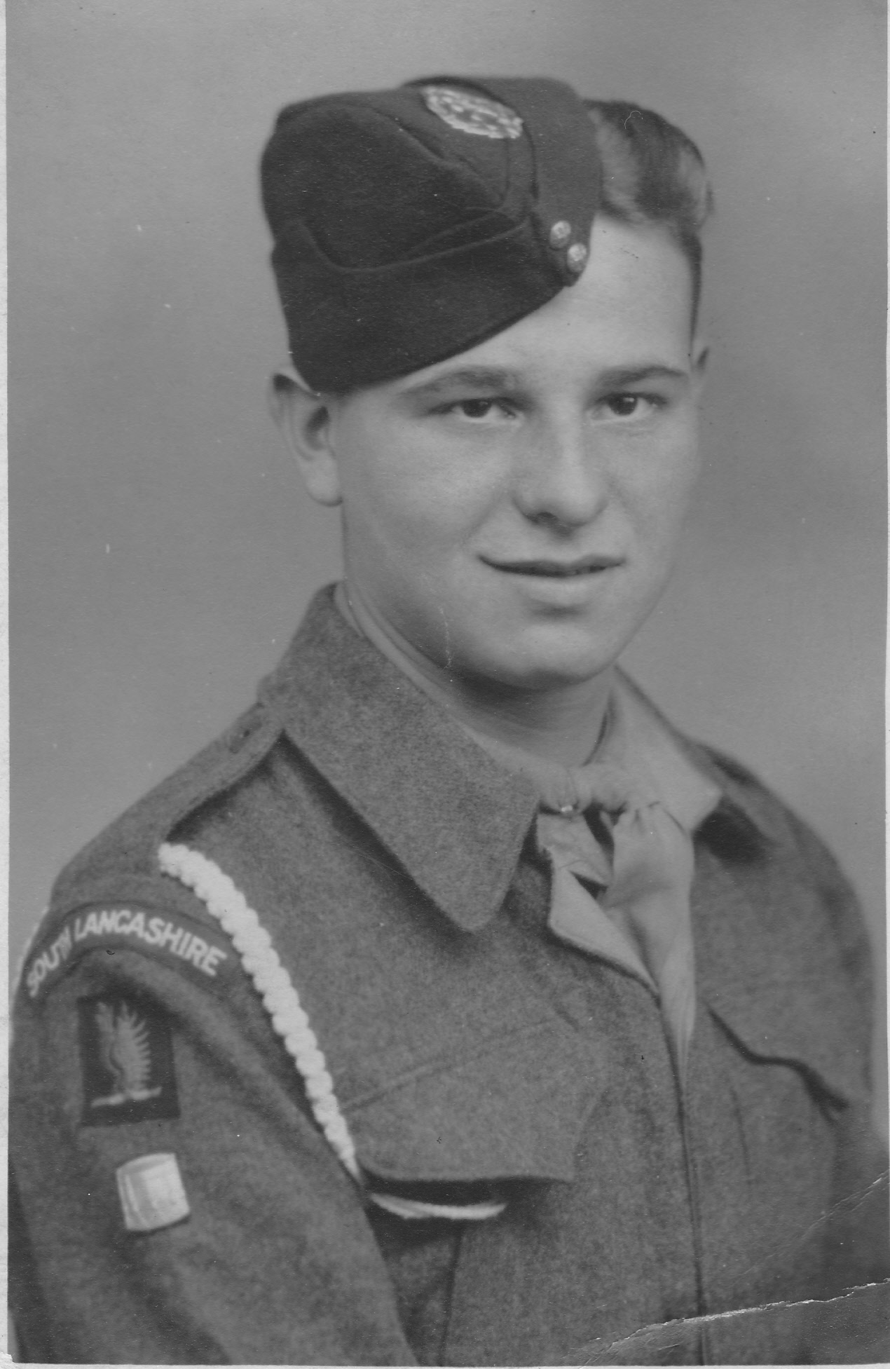

**Prayers at the Reception into Church:**

Almighty God,  
you love everything you have made  
and judge us with infinite mercy and justice.  
We rejoice in your promises of pardon, joy and peace  
to all those who love you.  
In your mercy turn the darkness of death into the dawn of new life  
and the sorrow of parting into the joy of heaven;  
through our Saviour Jesus Christ,  
who died, who rose again, and lives for evermore.

Heavenly Father, you have not made us for darkness and death,  
but for life with you for ever.  
Without you we have nothing to hope for;  
with you we have nothing to fear.  
Speak to us now your words of eternal life.  
Lift us into the light and peace of your presence,  
and set the glory of your love before us;  
through Jesus Christ our Lord.

God our Father,  
by raising Christ your Son you destroyed the power of death  
and opened for us the way to eternal life.  
As we remember before you our *sister Ron*,  
we ask you to comfort us in our loss  
and assure us of the promise of resurrection  
to eternal life for all who put their trust in you..  
May we know your presence and grace in our daily lives,  
by the Spirit you have given us;  
through Jesus Christ our Lord.

God our creator and redeemer, by your power Christ conquered death  
and entered into glory.  
Confident of his victory and claiming his promises,  
we entrust *Ron* to your mercy in the name of Jesus our Lord,  
who died and is alive and reigns with you, now and for ever

**A reading from the First Letter of Saint Peter**

Praise be to the God and Father of our Lord Jesus Christ! In his great mercy he has given us new birth into a living hope through the resurrection of Jesus Christ from the dead, and into an inheritance that can never perish, spoil or fade – kept in heaven for you, who through faith are shielded by God's power until the coming of the salvation that is ready to be revealed in the last time. In this you greatly rejoice, though now for a little while you may have had to suffer grief in all kinds of trials. These have come so that your faith – of greater worth than gold, which perishes even though refined by fire – may be proved genuine and may result in praise, glory and honour when Jesus Christ is revealed. Though you have not seen him, you love him; and even though you do not see him now, you believe in him and are filled with an inexpressible and glorious joy, for you are receiving the goal of your faith, the salvation of your souls.

This is the word of the Lord.

**All: Thanks be to God.**

Notes:

1. Used Agnus Dei 1 disc for music. Track 11 is In Paradisium and Track 12 Miserere. For placing the pall, started at 11 and left running. Just about managed to get all symbols on while stil playing and then finished service while Miserere playing. Still going as family sat for a couple of minutes before leaving church.